Vendor Performance Analysis
Business Problem:
Effective inventory and sales management are critical for optimizing profitability in the retail and wholesale industry. Companies need to ensure that they are not incurring losses due to inefficient pricing, poor inventory turnover, or vendor dependency. The goal of this analysis is to:
- Identify underperforming brands that require promotional or pricing adjustments.
- Determine top vendors contributing to sales and gross profit.
- Analyze the impact of bulk purchasing on unit costs.
- Assess inventory turnover to reduce holding costs and improve efficiency.
- Investigate the profitability variance between high-performing and low-performing vendors.
  - Structure of Dataset:
Here we have 4 CSV file:
    - sales.csv:
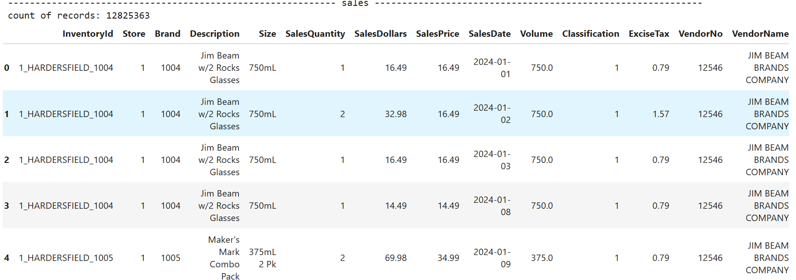
    - purchase.csv
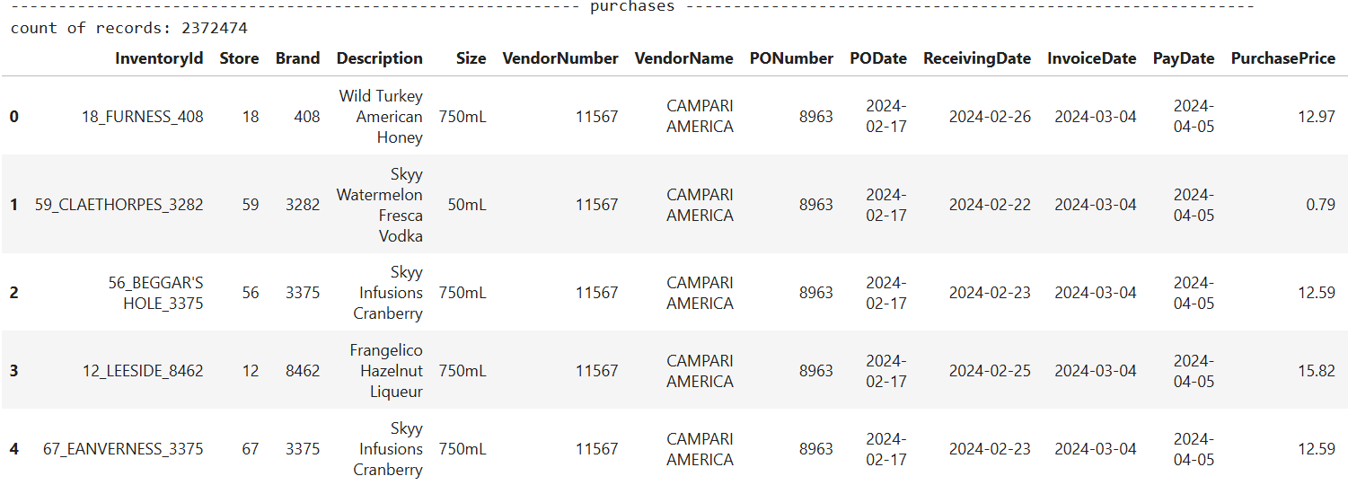
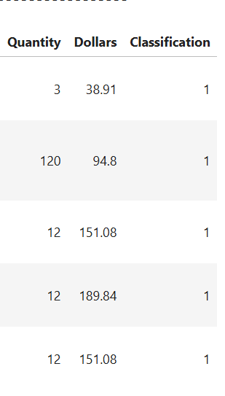

    - purchase_price.csv
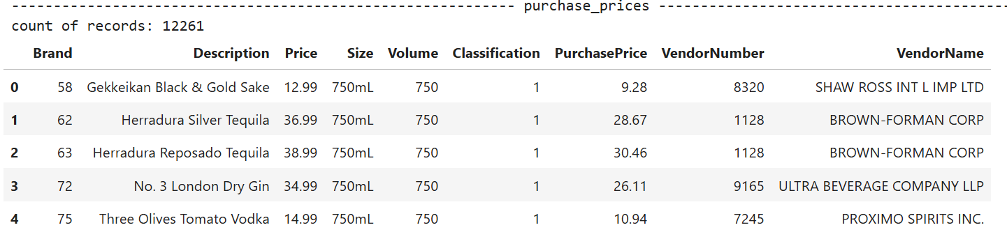
    - vendor_invoice.csv
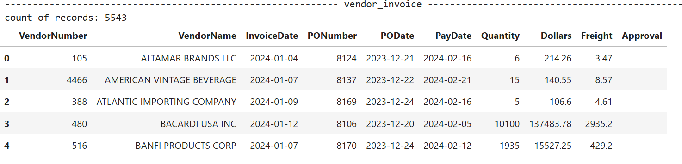
    - begin_inventory.csv & end_inventory.csv
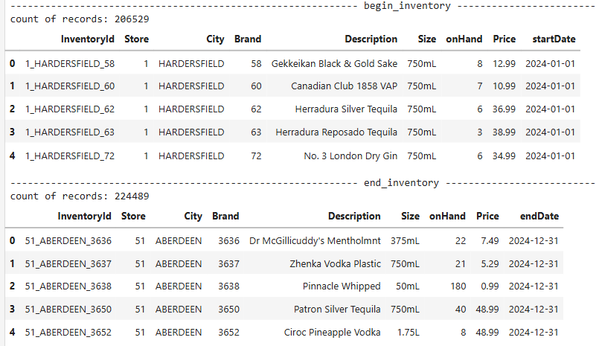

From the above tables, I have created 3 CTEs:

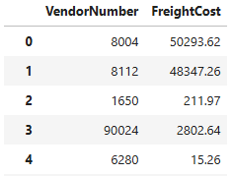
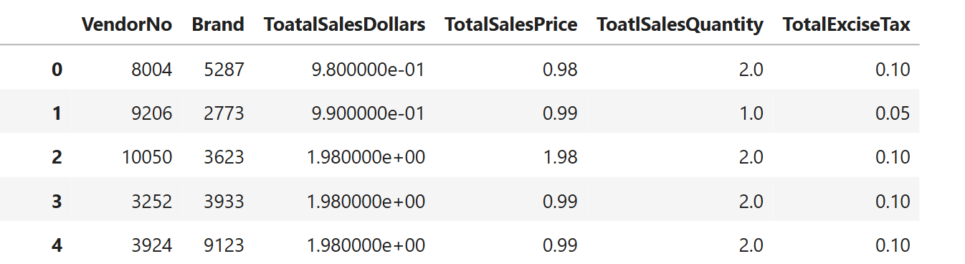

CTE1. FreightSummary CTE2. PurchaseSummary
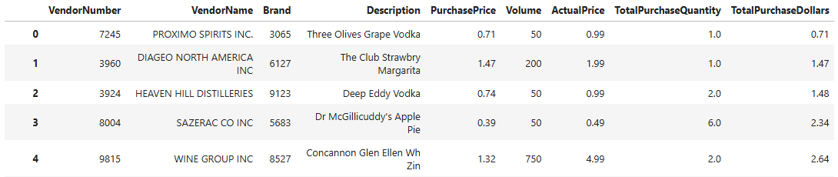
CTE3. SalesSummary

After combining all these CTEs. I have created a vendor_summary_table which represent the information related to purchase, sales and profit.

  - Vendor_summary_table:
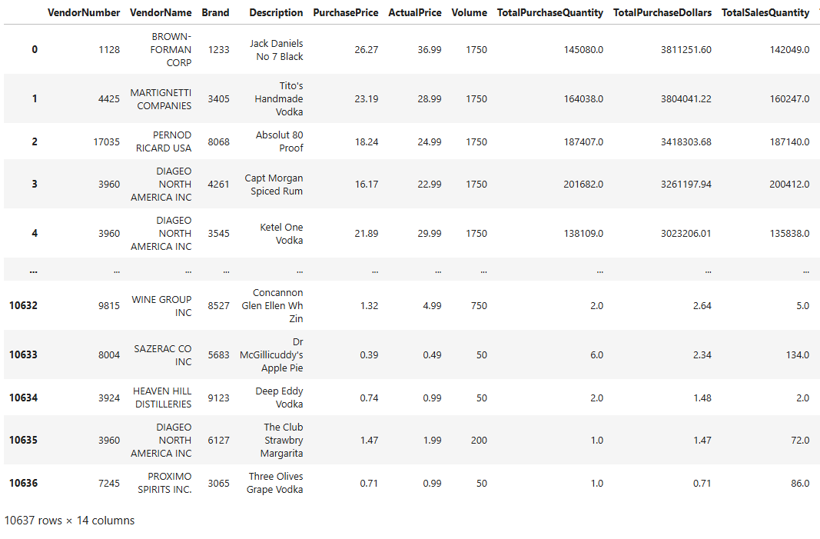
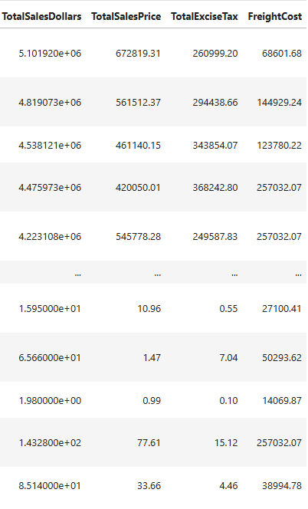

  - Performance Analysis:
Here I have created some KPIs for better understanding of the performance:
- GrossProfit = TotalSalesDollars – TotalPurchaseDollars

- ProfitMargin = (GrossProfit / TotalSalesDollars) x 100

- StockTurnover = TotalSalesQuantity / TotalPurchaseQuantity

- SalestoPurchaseRatio = TotalSalesDollars / TotalPurchaseDollars

After doing some cleaning removal of negative data from the table where GrossProfit <= 0 , ProfitMargin <=0 and TotalSalesQuantity <= 0.
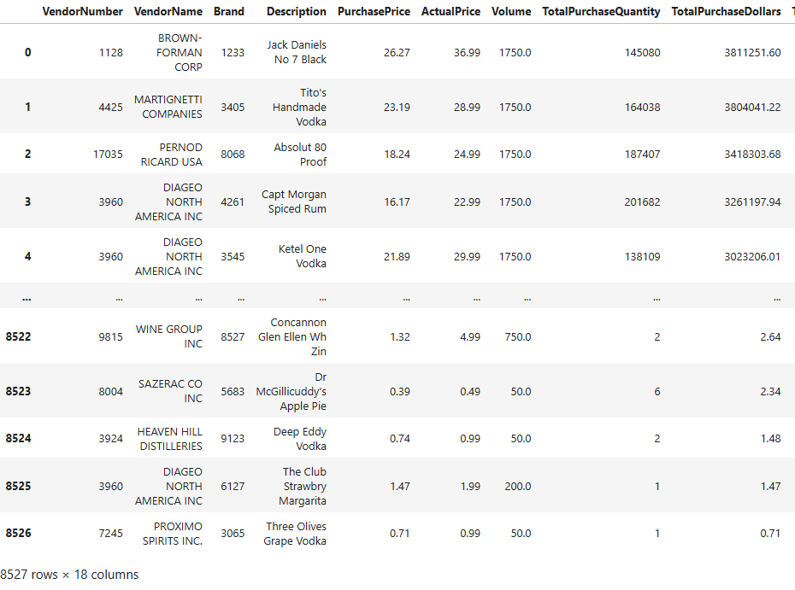
Then we get this table:

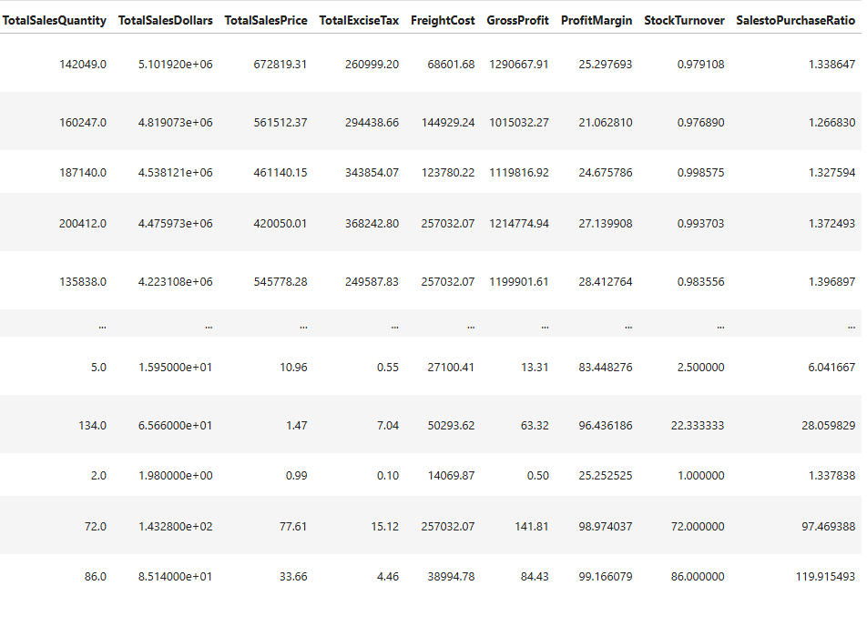

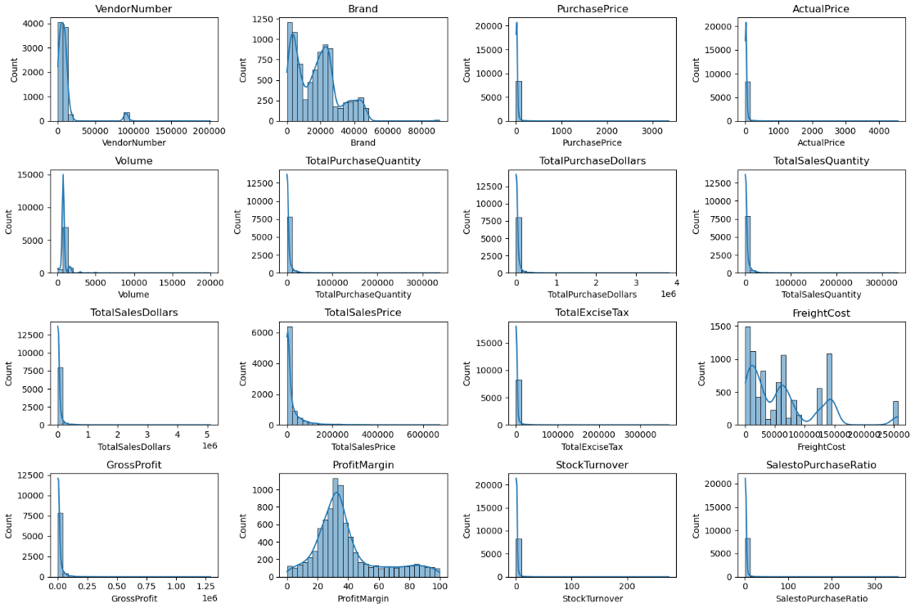
    - Understanding Vendor Performance Through Data Distributions

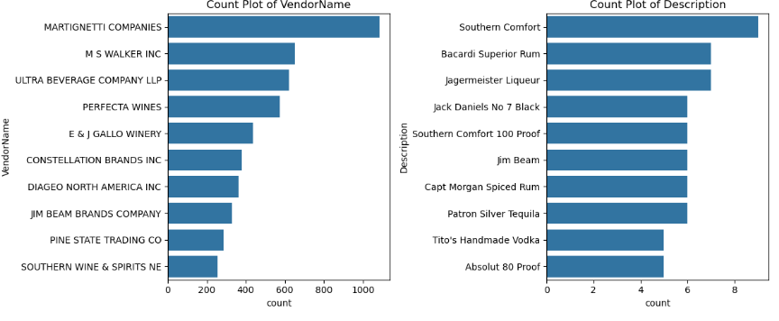
Vendor have highest appearance

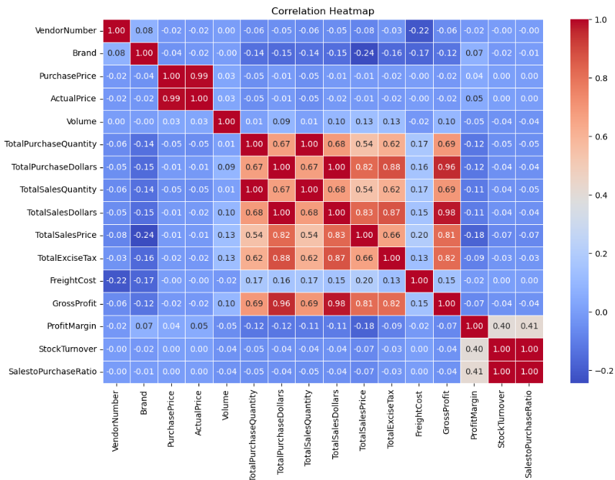
Correlation among the variables:

Question 1. Identify the brand that need Promotional or Pricing Adjustment which exhibit lower sales performance but higher profit margins.
For answering this first we have to extract the information about the total sales and the average profit margin of a product so we can find the list of products which have low sales but high profit margin.
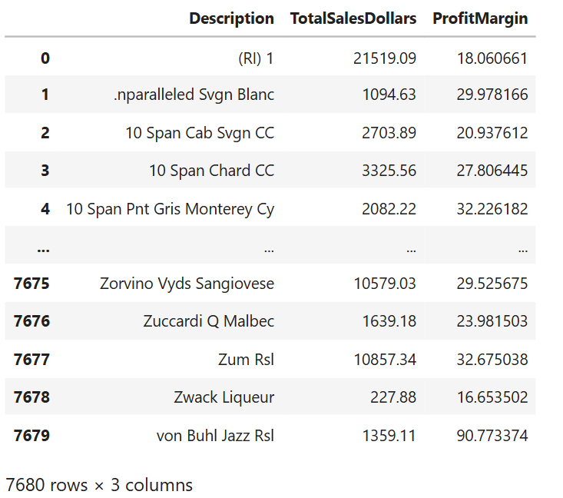
Here we have calculated the sum of TotalSalesDollars and average of ProfitMargin.

For finding the prodicts which need the promotion we have considered tow thing:
1. low_sales_threshold = brand_performance['TotalSalesDollars'].quantile(0.15)
2. high_margin_threshold = brand_performance['ProfitMargin'].quantile(0.85)
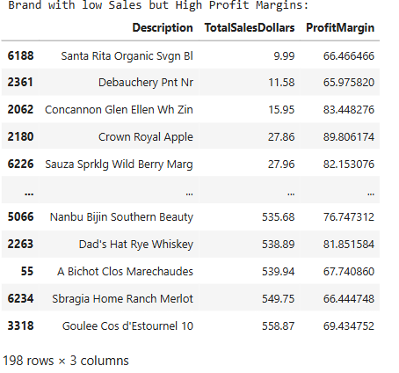
Then we have calculate those brands which have TotalSalesDollars <= low_sales_threshold and profitMargin >= high_margin_threshold.
Scatter Plot for better understanding:

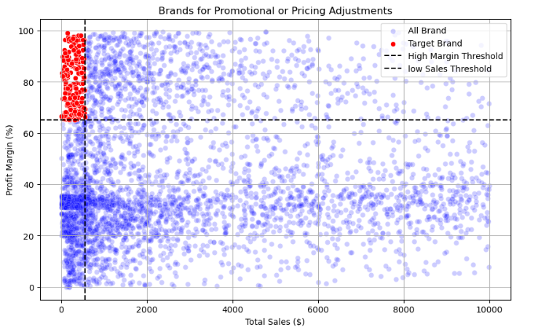
Question 2. Which vendor and brand demonstrate the highest sales performance?
Here we group the data by TotalSalesDollars and select the top 10 vendors and brands by sale.
top_vendors = df.groupby("VendorName")["TotalSalesDollars"].sum().nlargest(10)
top_brands = df.groupby("Description")["TotalSalesDollars"].sum().nlargest(10)
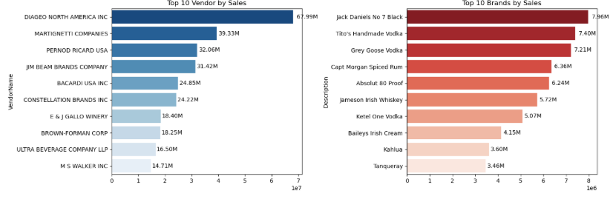

Question 3. Which vendor contribute the most to total Purchase dollars?
Here we have created a table (top_vendors) contain the total purchase contribution of vendors
vendor_performance['PurchaseContribution%'] = (vendor_performance['TotalPurchaseDollars']/vendor_performance['TotalPurchaseDollars'].sum())*100
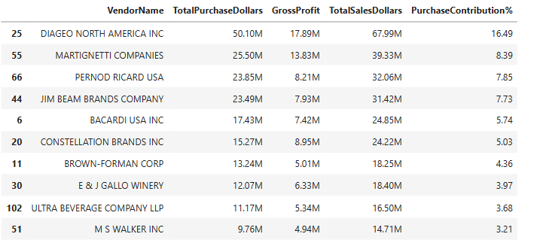
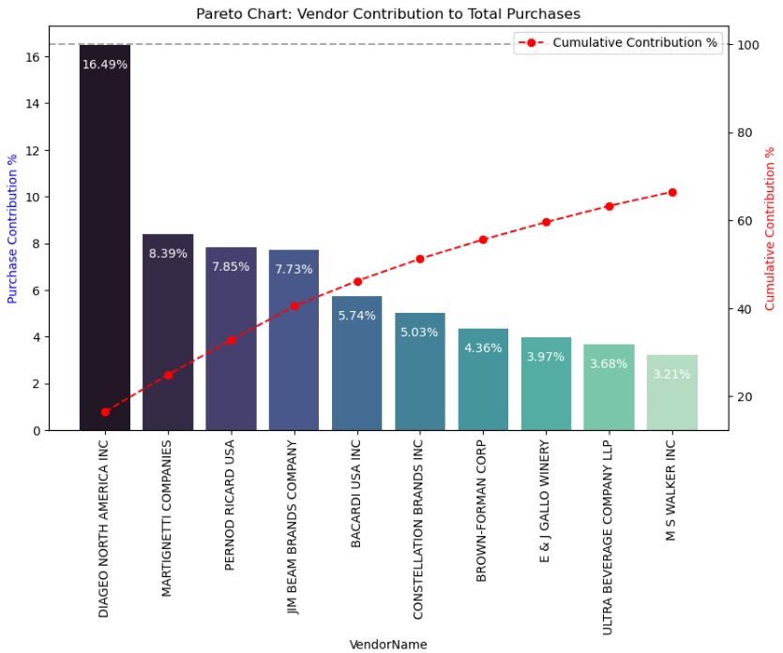
Graph for better visualization:
Question 4. How much of total procurement is dependent on top vendors?
Total Purchase Contribution of top 10 vendor is 66.45% which we can calculate by using simple code: top_vendors['PurchaseContribution%'].sum()
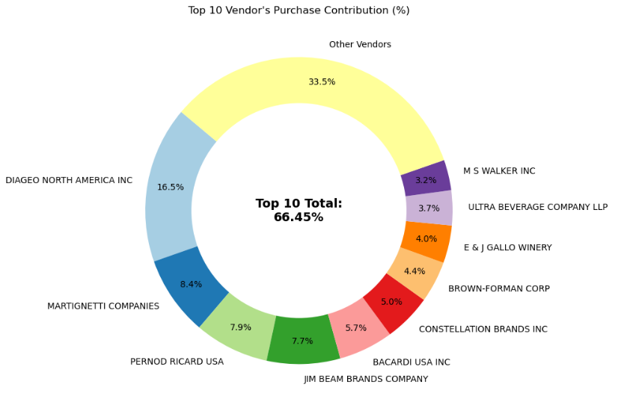
Donut Chart for better understanding:
Total Purchase Price = 303.84M
Contribution due to top 10 vendor = 201.91M
66.45% of total procurement depend on the top 10 vendors
Question 5. Does purchasing in bulk reduce the unit price, and what is the optimal purchase volume for cost savings?
For answering this question we have to create a new column UnitPurchasePrice for analysing the impact of bulk purchasing in purchase price.
df['UnitPurchasePrice'] = df['TotalPurchaseDollars'] / df['TotalPurchaseQuantity']
Then we have to create another column Ordersize to split the TotalPurchaseQuantity into 3 part {Large, Medium, Small} for better analysis.
df['OrderSize'] = pd.qcut(df['TotalPurchaseQuantity'], q=3, labels=["Small", "Medium", "Large"])
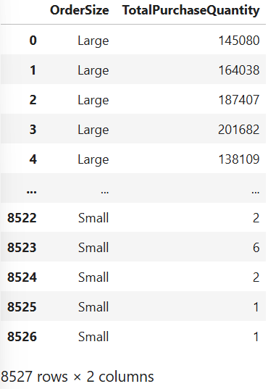
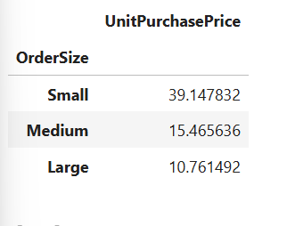

Question 6. Which vendor have low inventory turnover, indicating excess stock and slow-moving products?
Those vendor whose StockTurnover is less than one are that vendors who are not performing well. So to find that we should use this query:
df[df['StockTurnover']<1].groupby('VendorName')[['StockTurnover']].mean().sort_values('StockTurnover', ascending = True).head(10)
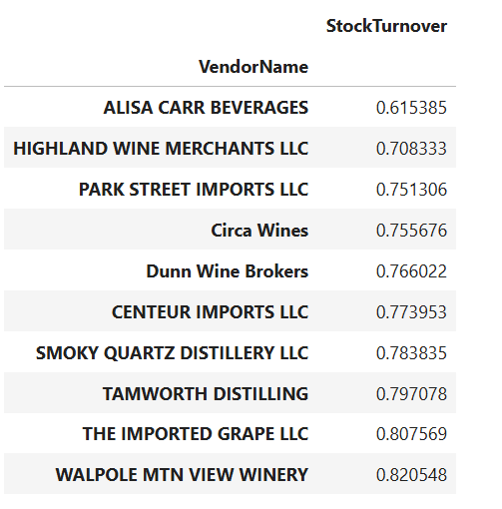
Here we are taking top 10 underperforming vendor

Question 7. How much capital is locked in unsold inventory per vendor, and which vendor contribute the most to it?
We can calculate that by finding the difference between TotalPurchaseQuantity and TotalSalesQuantity then ultiply that with PurchasePrice
df['UnsoldInventoryValue'] = (df['TotalPurchaseQuantity']-df['TotalSalesQuantity'])*df['PurchasePrice']
Total Unsold Capital: 2.70M
Then, the vendor which are contributing more in this are :
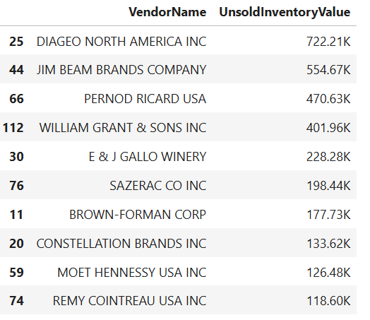
inventory_value_per_vendor = df.groupby("VendorName")["UnsoldInventoryValue"].sum().reset_index()
Question 8. What is the 95% confidence intervals for profit margin of top-performing and low-performing vendors.
Firstly we have created two dataset one for top performing vendors and other for low performing vendors.
top_threshold = df['TotalSalesDollars'].quantile(0.75)
low_threshold = df['TotalSalesDollars'].quantile(0.25)
top_vendors = df[df["TotalSalesDollars"] >= top_threshold]["ProfitMargin"].dropna()
low_vendors = df[df["TotalSalesDollars"] <= low_threshold]["ProfitMargin"].dropna()
Here we will be doing T test for finding the 95% confidence interval for low and top performing vendors because we don’t know about the Standard Deviation of population data.
Then we define a function for that:
def confidence_interval(data, confidence=0.95):
mean_val = np.mean(data)
std_err = np.std(data, ddof=1) / np.sqrt(len(data)) # Standard error
t_critical = stats.t.ppf((1 + confidence) / 2, df=len(data) - 1)
margin_of_error = t_critical * std_err
return mean_val, mean_val - margin_of_error, mean_val + margin_of_error
top_mean, top_lower, top_upper = confidence_interval(top_vendors)
low_mean, low_lower, low_upper = confidence_interval(low_vendors)
Graph for better understanding:
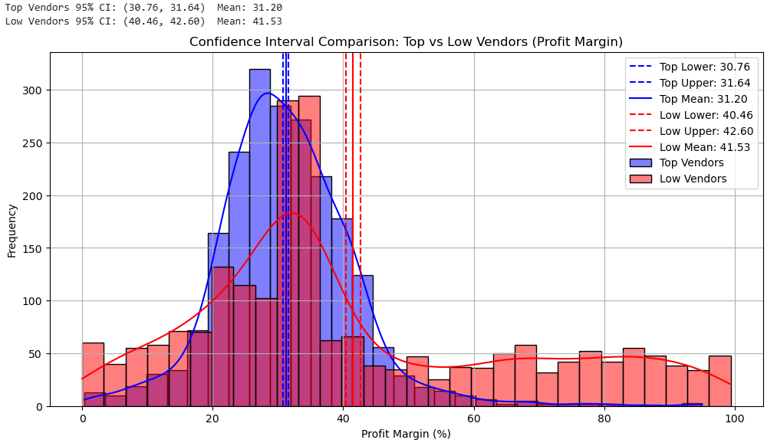

Question 9. Is there a significant difference in profit margin between top-performing and low-performing vendor?
Here we will perform Two-Sample T-Test:
H_{o}: There is no Significant difference.
H₁: There is Significant difference.
t_stat, p_value = ttest_ind(top_vendors, low_vendors, equal_var=False)
Here, t_stat = -17.5409 and p_value = 0.0000
Thus:
Reject H_{o}: There is a significant difference in profit margin between top and low_performing vendors.

